Maintenance Outsourcing
Maintenance on the spot
Modern industrial systems must be available at any time and must run with greatest efficiency. A long-term reliability and continuous productivity must be ensured permanently. Moreover, the conformity with the latest Health and Safety Standards is of utmost importance. All this must be achieved with a maintenance budget that can be planned.
To ensure the continuous improvements on a long-term basis, too, your company can outsource the maintenance including the maintenance management and the maintenance resources. As a reliable partner for your company that wants to concentrate on its core business, Siemens will assume the responsibility for the organization and the application of the maintenance. With performance-based maintenance contracts, Siemens provides you with an increased overall equipment efficiency (OEE) and with a higher financial transparency, hence a better control of the maintenance budget.
Long-term contracts become an important and strategic decision for your company. Profiting from our multiple experiences, we advise and support you in finding the best decision for both parties. The contract model is based on your individual needs in agreement with your specific business objectives. Benefit indexes we elaborate together will be the foundation of this partnership. Siemens is proud of its win-win cooperations, which are successful for both sides.

Outsourcing  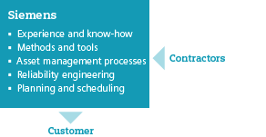 | - With Siemens as your partner for asset management you can concentrate on your core business  - A performance-based contract provides you with transparency, control and additional financial benefits!

Long-term maintenance plan to ensure lasting, maximum availability
From the very beginning, we think about the result and take all your long-term considerations into account. In close coordination with you, we go through the following steps together.
You benefit from the following advantages:
- Increase of the overall equipment use, increase of the system availability, i.e. the production capacity you can sell.
- Introduction of new and improved asset management processes, optimization and increase of the availability of resources (staff), in combination with a high cost efficiency.
- Improved quality of the maintenance measures for more reliability and a longer service life of your equipment; less capital requirements.
- Reduction of spare parts stocks and costs and increase of the stock security of critical spare parts.
- Reduction of the risk and guidance to well-founded decisions in every step of the optimization process.
- Integration of the concept of continuous improvement in the daily routines.
- Increase of motivation and special knowledge of the maintenance personnel.
- Improved control of maintenance costs and reporting, better transparency and optimization of the cost planning and prognosis processes.
- Inproved maintenance planning, optimization of the production planning and the supply chain processes related to the asset management processes.
By increasing the optimum capacity and cost effectiveness in combination with our energy and environment service, we support you in increasing the energy efficiency and in reducing the CO2 emissions. Together we will make your asset management a real competitive advantage for your company!
Asset management - from a cost factor to a value-increasing success factor!

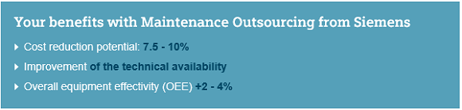

The concept for a successful asset management combines the necessary one-time effects with the implementation of standard processes and tools, which will lead you to a long-term success. All the optimization projects focus on the "human factor". This means an active change management and requires the continuous attention of the corporate management. The risk that staff fall back into old habits and that the efficiency sinks again is rather high. Siemens has the experience which is needed in handling these issues competently and is prepared for a long-term partnership to prevent these risks.
Numerous customers have already made the step and trusted Siemens Industry Services with their industrial maintenance.

Further information
- Brochure: Maintenance as a core competence (1,7 MB)
- Contact: ipm.industry@siemens.com

Proceed as follows
Are you interested in this service? If you are, contact your Siemens Contact Person. They will be glad to help and are available for more detailed information about this service.

